FinRL Project : Data Preprocessing

We can use the function DataProcesser for data preprocessing, including data accessing and cleaning, and feature engineering.

Data Cleaning
Raw data retrieved from different data sources are usually of various formats and have erroneous or NaN data (missing data) to different extents, making data cleaning highly time-consuming. In FinRL-Meta, we automate the data cleaning process.
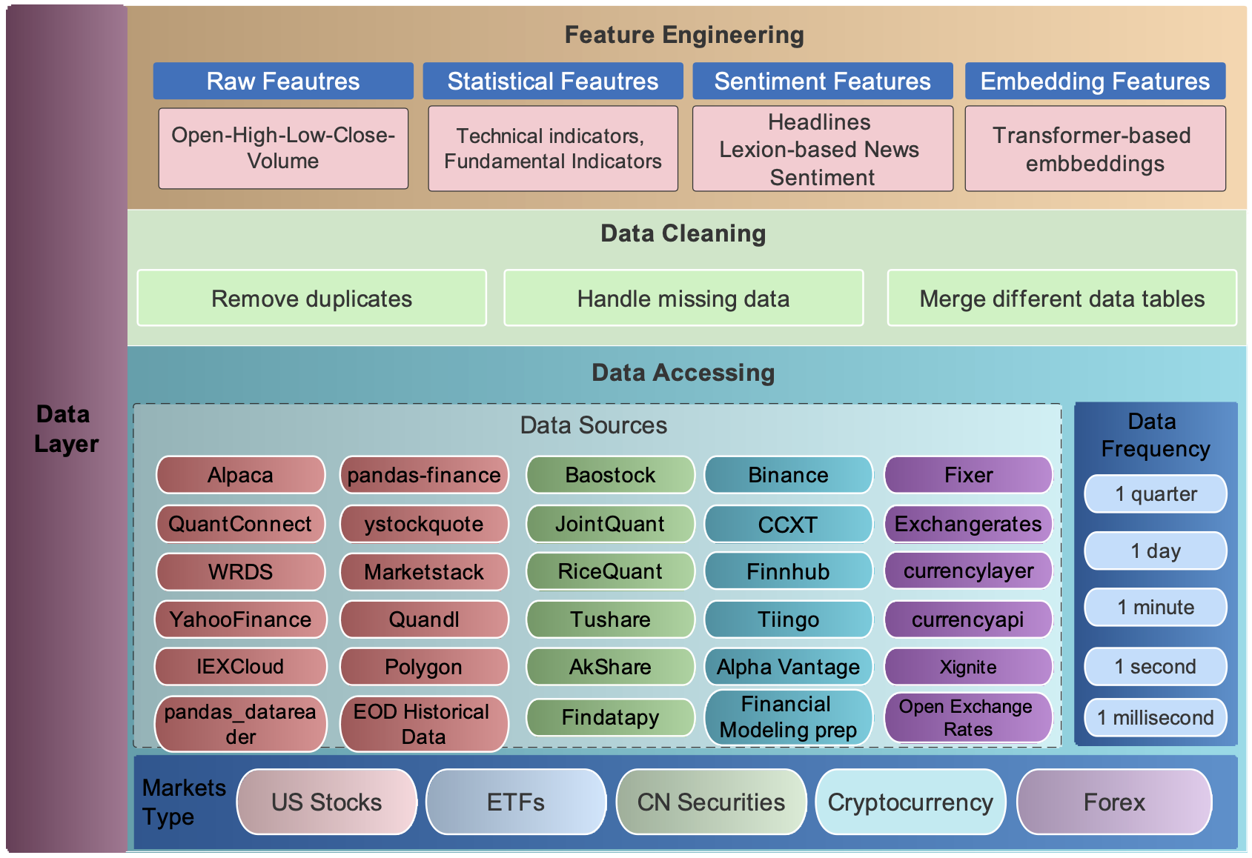
NaN Datas:
NaN data are usually different for various time frequencies. For Low-frequency data, except few stocks with extremely low liquidity, the few NaN values usually mean suspension during that time interval. While for high-frequency data, NaN values are pervasive, which usually means no transaction during that time interval. To reduce the simulation-to-reality gap considering of data efficiency, we provide different solutions for these two cases.
- In the low-frequency case, we directly delete the rows with NaN values, reflecting suspension in simulated trading environments.
- On OHLCV: The low data efficiency of the dropping method is unacceptable. Instead, we take an improved forward filling method. We fill the open, high, low, close columns with the last valid value of close price and the volume column with 0, which is a standard method in practice.
Adding Technical Indicators
We automate the calculation of technical indicators by connecting the Stockstats or TAlib library in our data processor. Common technical indicators including Moving Average Convergence Divergence (MACD), Relative Strength Index (RSI), Average Directional Index (ADX), and Commodity Channel Index (CCI), and so on, are supported. Users can also quickly add indicators from other libraries, or add the user-defined features directly.

You can add technical indicators and turbulence factor to dataframe. Just set the use_technical_indicator=True, use_vix=True and use_turbulence=True
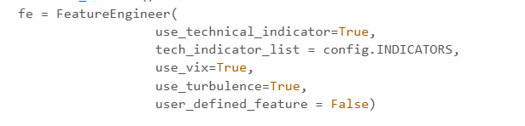

Define Environment Parameters (env_kwargs)
We automate the setup of the trading environment by defining env_kwargs, which controls how the reinforcement learning (RL) agent interacts with the market. Key parameters such as the state space, action space, initial capital, transaction costs, and reward scaling can be customized to fit different trading strategies.
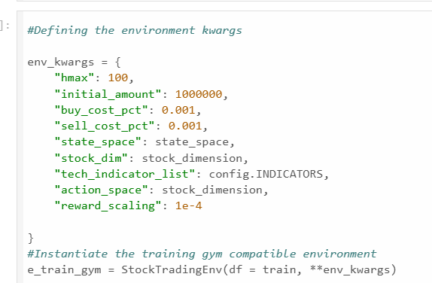
These parameters configure how the environment behaves and what the agent interacts with:
- "hmax": The maximum number of shares that can be traded in a single transaction (prevents unrealistic trading).
- "initial_amount": The starting capital for the agent in the simulation.
- "buy_cost_pct" and "sell_cost_pct": Transaction fees as a percentage, adding realism to the simulation.
- "state_space": The input size (number of features) that defines the agent's observations.
- "stock_dim": The number of different stocks included in the simulation environment.
- "tech_indicator_list": A list of technical indicators (e.g., RSI, MACD) used as features for decision-making.
- "action_space": The number of stocks the agent can trade, matching the stock dimension.
- "reward_scaling": A scaling factor applied to rewards to normalize their magnitude and stabilize training.

The Custom Functions to be used in Preprocessing
Users can add their features by two ways:
1) Write user-defined feature extraction functions directly. The returned features will be added to a feature array.
2) Store the features in a file, and move it to a specified folder. Then, these features will be obtained by reading from the specified file.

FinRL provides FeatureEngineer, which you can extend to define custom feature extraction methods.

